Day 2

Story

McSkidy needs to check if any other employee elves have left/been affected by Grinch Industries attack, but the systems that hold the employee information have been hacked. Can you hack them back to determine if the other teams in the Best Festival Company have been affected?

Learning Objectives



* Understanding the underlying technology of web servers and how the web communicates.
* Understand what cookies are and their purpose.
* Learn how to manipulate and manage cookies for malicious use.

HTTP(S)

For your computer and a webserver to communicate with each other, an intermediary protocol is required. This is where the HTTP (Hypertext Transfer Protocol) is introduced! The HTTP protocol is a client-server protocol to provide communication between a client and a webserver. HTTP requests are similar to a standard TCP network request; however, HTTP adds specific headers to the request to identify the protocol and other information.

When an HTTP request is crafted, the *method* and *target* header will always be included. The target header will specify what to retrieve from the server, and the method header will specify how.

When retrieving information from a web server, it is common to use the *GET* method, such as loading a picture.

When sending data to a web server, it is common to use the *POST* method, such as sending login information.

**Example Request**

GET / HTTP/1.1

Host: tryhackme.com

User-Agent: Mozilla/5.0 Firefox/87.0

Referer: https://tryhackme.com/

Once the server receives a request, it will send back a response, including any requested content if successful and a status code. The status code is used to tell the client browser how the webserver interpreted the request. The most common "successful" status code is HTTP 200 OK.

**Example Response**

HTTP/1.1 200 OK

Server: nginx/1.15.8

Date: Wednesday, 24 Nov 2021 13:34:03 GMT

Content-Type: text/html

Content-Length: 98

<html>

<head>

<title>Advent of Cyber</title>

</head>

<body>

Welcome To Advent of Cyber!

</body>

</html>

The protocol itself is only one small piece of the puzzle; once content is retrieved from the web server, your browser needs a way to interpret and render the information sent. Web applications are commonly formatted in HTML (HyperText Markup Language), rendered, and styled in CSS (Cascading Style Sheets). JavaScript is also commonly used to provide additional functionality.

In today's web environment, the use of web frameworks has significantly increased in popularity. Most modern web applications use many web frameworks and other web solutions that an end-user does not see or interact with.

For more information about HTTP requests, methods, and headers, check out the [Web Fundamentals](https://tryhackme.com/room/webfundamentals) room!

Cookies



HTTP is a stateless protocol. When you send requests to a web server, the server cannot distinguish your request from someone else's request.. To solve the stateless problem and identify different users and access levels, the webserver will assign cookies to create and manage a stateful session between client and server.

Cookies are tiny pieces of data (metadata) or information locally stored on your computer that are sent to the server when you make a request.

Cookies can be assigned any name and any value allowing the webserver to store any information it wants. Today we will be focusing on authentication cookies, also known as session cookies. Authentication or session cookies are used to identify you and what access level is attached to your session.

Below is a diagram describing assigning and using a cookie from the initial request to the session request.

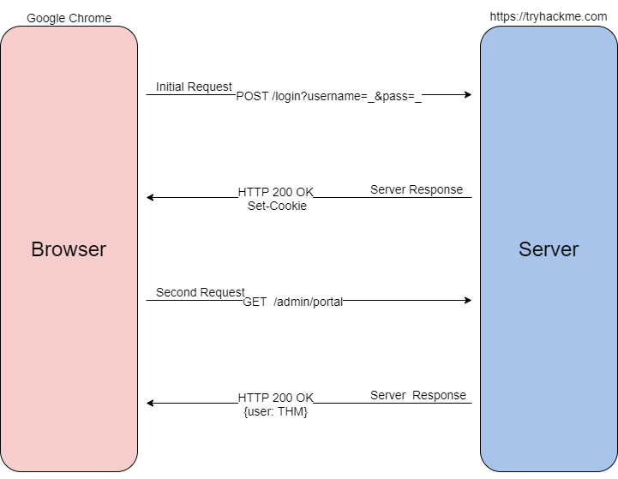

To begin the process, when you send a request such as a login request, your browser will send that information typically as a POST request to the webserver. The web server will verify that it received the data and set a unique cookie; as previously mentioned, cookies are arbitrary, and values are determined by best-practice or the web developer. Once the cookie is assigned, as long as the cookie stays locally stored in your browser, all future GET requests will be automatically sent with that cookie to identify you and your access level. Once the server receives your GET request and cookie, it will locate and de-serialize your session. Deserialization is the process of taking a data format such as JSON and rebuilding it as an object. If successful, the webserver will reply to your request with a 200 response.

Now that we understand what cookies are and how they are used, let us dive into their contents.

Cookie Components

Cookies are made up of 11 different components; you can find an explanation of each component in the table below.

|  |  |  |
| --- | --- | --- |
| **Component** | **Purpose** | **Example** |
| Name | Unique cookie identifier (arbitrarily set by web-server). Always paired with the value component. | SessionID |
| Value | Unique cookie value (arbitrarily set by web-server). Always paired with the name component | sty1z3kz11mpqxjv648mqwlx4ginpt6c |
| Domain | Originating domain of the cookie. Sets the scope of the cookie. | .tryhackme.com |
| Path | Local path to cookie. Sets the scope of the cookie. | / |
| Expires/Max-age | Date/time at which cookies expires | 2022-11-11T15:39:04.166Z |
| Size | Disk size of the cookie in bytes. This is typically {Name+Value} | 91 |
| HttpOnly | Cookie cannot be accessed through client-side scripts | (indicated by a checkmark) |
| Secure | Cookie is only sent over HTTPS | (indicated by a checkmark) |
| SameSite | Specifies when a cookie is sent through cross-site requests | none |
| SameParty | Extends functionality of *SameSite* attribute to First-Party sets. | (indicated by a checkmark) |
| Priority | Defines the importance of a cookie. Determines whether it should be removed or held on to | High |

Looking at all the components of a cookie may seem intimidating. There is no need to worry as attackers; we only need to concern ourselves with two components: Name and Value; the rest of the components are handled by the webserver.

Cookie components are always prepared in pairs. The main pair is name-value; this will define the name of the cookie and the value of the name. The second pair is the attribute-value pair; this will define an attribute of the cookie and the value of the attribute. Below is an example of what Set-Cookie syntax looks like.

Set-Cookie: <cookie-name>=<cookie-value>; Domain=<domain-value>; Secure; HttpOnly

Cookie Manipulation



Cookie manipulation is taking a cookie and modifying it to obtain unintended behavior determined by the web developer. Cookie manipulation is possible because cookies are stored locally on your host system, meaning you have complete control over them and modify them as you please.

To begin modifying and manipulating cookies, we need to open our developer tools. In Google Chrome, developer tools are known as the *"Chrome Developer Tools,"* and in Mozilla Firefox, they are known as the *"Firefox Developer Tools."*

Developer tools can be accessed by pressing F12 or Ctrl+Shift+I. Once developer tools are open, to access your cookies, navigate to the Storage tab in Firefox or Application tab in Chrome/Edge; select the Cookies dropdown on the left-hand side of the console.

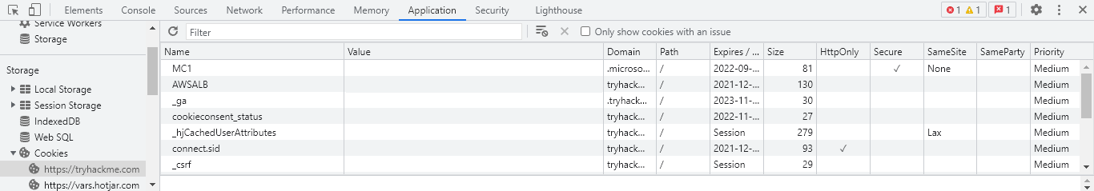

Cookie values may seem random at first; however, they often have an encoded value or meaning behind them that can be decoded to a non-arbitrary value such as a Javascript object.

From an attacker's perspective, you can decode the cookie value to identify the underlying objects. Once you have identified the underlying objects, you can modify them to what you want. To use the cookie, you will need to encode it back to the original encoding and replace the cookie value. Below is an example of a decoded cookie value.

{firstName:"John", lastName:"Doe", age:50, eyeColor:"blue"

Now that we have all of the pieces of cookies and how to manipulate them, we can put them all together to gain unintended access.

Below is a summary of how cookie values could be manipulated.

1. Obtain a cookie value from registering or signing up for an account.
2. Decode the cookie value.
3. Identify the object notation or structure of the cookie.
4. Change the parameters inside the object to a different parameter with a higher privilege level, such as admin or administrator.
5. Re-encode the cookie and insert the cookie into the value space; this can be done by double-clicking the value box.
6. Action the cookie; this can be done by refreshing the page or logging in.

Additional Resources

﻿For more information about HTTP(s) and cookies, check out these other TryHackMe rooms.

* HTTP: <https://tryhackme.com/jr/httpindetail>
* Authentication: <https://tryhackme.com/jr/authenticationbypass>